CS 405 Project 1

Kaan Bilgili 27983

Task 1: For this task I simply gave the prompt to ChatGPT. It returned the result as 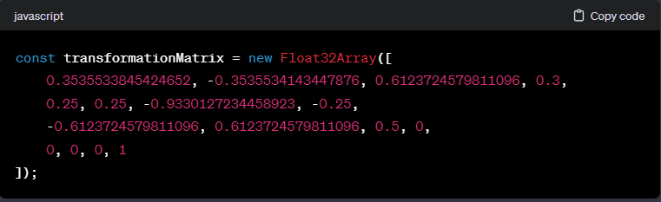

And when I applied the generated cube is:

Not a cube.

Which generates:

Still not a cube so I gave up hope. (Better than the first result, at least it resembles a cube.)

Task 2: For this task I used the given functionalities. To calculate the transformation matrix I first multiply vertices rotationY and rotationZ. Then I multiply the result with rotationX. Then I multiply the result with scaleMatrix. Then finally I multiply the result with translationMatrix. I do the multiplications considering the ordering M = (translation)(shear)(scaling)(rotation). Such that as I said I first multiply rotationZ and rotation with Z being the rightmost, or on the final matrix multiplication I put the translation on the left and result on the right. The cube generated:

I think the reason ChatGPT gets the wrong results is that it mixes up the order of multiplication.

Task 3: For this task I have created 2 chats. In the first chat I felt like we weren’t getting anywhere so I created a second chat and it created the function in the first try.

The first chat: <https://chat.openai.com/share/9c720acd-7abb-4b01-bd5e-db0c3ee9a759>

The second chat: https://chat.openai.com/share/391dfef5-bc77-4bb0-bdb1-8eead074a27e

The function creates a smooth animation by calculating where the matrix should be at given time with accordance to the start time. It returns a matrix by interpolating the transformation matrix I get in task 2 and the identity matrix.